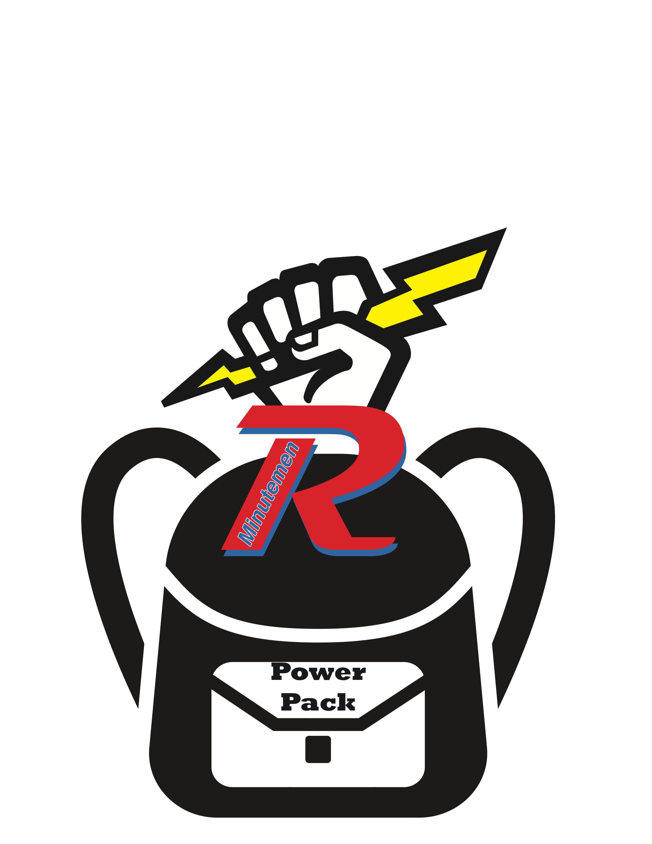
Revere Power Pack Program

A non-profit organization whose goal is to provide children in the
Revere Community with adequate food on weekends.

Each weekend when school is in session.

Parents/guardians of children who are eligible for free or reduced lunch have the
option to “Opt In.” Others may be enrolled throughout the school year by a
school administrator should the need arise.

Three breakfasts, two snacks, and three entree items are packed by members
of The National Honor Society each school week based upon a preset
menu. Preschoolers receive additional breakfasts and snacks as they have longer
weekends.Extra food is provided for long weekends or holiday breaks. The food is
discretely distributed to the children. Neither the Revere Power Pack Program nor
the members of National Honor Society know the recipients’ names.

No child should be concerned about having enough food. Events
sometimes change circumstances and finances within a household and, as a
community, we need to be prepared to assist when needed.

Monetary donations made payable to the Revere Power Pack Program are tax deductible and may be mailed to The Revere Power Pack Program, PO Box 648, Bath, Ohio 44210.

